Product Recommendation System for B2B E-Commerce Site  
Emphasizing on User Behavior Data with A Fusion Approach

Md. Ashfaqul Haque, Israt Jahan Dristy, Shihab Sharar, Annajiat Alim Rasel

Department of Computer Science & Engineering

Brac University, Mohakhali, Dhaka – 1212, Bangladesh   
md.ashfaqul.haque@g.bracu.ac.bd, israt.jahan.dristy@g.bracu.ac.bd, shihab.sharar@g.bracu.ac.bd, annajiat@gmail.com

Abstract

The target of a recommendation system in E-commerce is to provide user’s desirable product which makes any particular user eager to buy. For achieving better accuracy in providing the best user experience many filtering methods are used for the recommendation which not providing the best quality of service. Our proposed method working is comparing the price of the same product from different sellers along with considering its user reviews which is an NLP-based deep learning approach. And on top of that, this method is proposed on the basis b2b type e-commerce business platforms like Draraz.com, AliExpress, Amazon, etc.

Introduction *[1]*

Product recommendation system refers to the system when a user searches for any product and is provided with similar content for which he/she is wishing. A reliable product recommendation system for any type of E-commerce platform is beneficial for both sellers and users. The most challenging task in online business is to provide the consumer with the best service. In an e-commerce business platform, it’s a challenging task to provide the best user-friendly experience which also brings profitable outcomes to the seller. And for that, there is no alternative way of a proper product recommendation system. Moreover, there are different types of e-commerce sites each having different business models or strategies so that’s why it's very hard to provide a single approach for all sites. For this reason, we are considering only the Business to Business (B2B) e-commerce model for our approach following. There is a lot of recommendation system has been applied for product recommendation as to its nowhere near perfection, so new methods are being applied now and then. That’s why a huge opportunity is lying ahead for the improvement of this field. Here, some recent approaches of our predecessor’s which we have followed. A hybrid recommendation system has been applied in this work the recommendation system provides recommendations on the user’s interest. In this context, web usage mining and content mining with additional factors are proposed (Bajpai et al, 2020). A machine learning-based customer sentiment analysis is motivated towards applying Machine Learning algorithms for learning, analyzing, and classifying the product information and the shop information based on the customer experience (Shanshan Yi et al, 2020). Here, Reviews are examined utilizing an optimized Artificial Neural Network (ANN) that exhibits noticeable improvement over regular ANN on real-time extracted data of reviews in a sentiment analysis technique with CF for Quality Recommendations. (Nehete et al, 2021). A non-personalized Recommender System has been applied with unsupervised and supervised architectures to solve the product and basket embeddings for a recommendation engine (Yildirim et al,2020). Then another one has considered users' comments for recommendation and mended it with other recommendation systems (Azhaguramyaa et al,2020). Another recommendation system was analyzed with the Linear Regression model (Karthikeyan et al,2017).

Proposed Methodology

In our proposed method, we have given a combining approach with the previously used method in which a web-based recommendation in an e-commerce system has been shown in Fig 1.

Here in our method, we have given an approach that takes user data first and tokenizes it to extract key features for recommending products in accordance with considering the data of the users. Here user data refers to the extracted data of the user’s selected product from searched items. By combining the key features from current search and analytics from previously used algorithms some recommendations of similar products are generated. Now from these similar products prices and user reviews are extracted and compared with previous users’ purchase data to generate the best final hierarchical recommendation for the user with a feasible unsupervised approach.

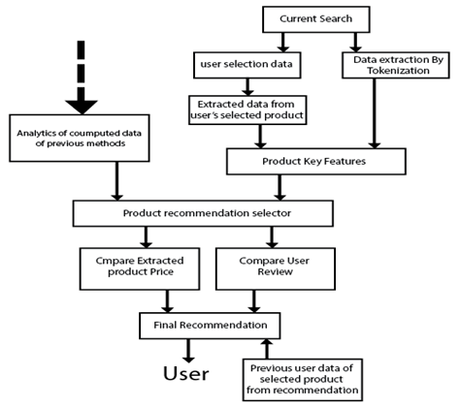

Fig 1. Methodology.

Conclusion

In our proposed method we have provided a recommendation system for b2b based eCommerce sites using NLP-based techniques. As training data is scarcer, we have proposed an unsupervised learning approach. Which works in combination with existing methods based on previous research works. User purchase feedback from the recommendation is considered for the betterment of the system.

References

V. Bajpai, “A Hybrid Recommendation System for ECommerce,” *International Journal of Innovative Research In Computing*, ISBN No. 978-93-5416-539-9, 2020.

S. Yi, X. Liu, “Machine learning based customer sentiment analysis for recommending shoppers, shops based on customers’ review,” *Complex & Intelligent Systems*, 6. 10.1007/s40747-020-00155-2.

S. P. Nehete, S. R. Devane, “Need of Sentiments Analysis with CF for Quality Recommendations,” *EJECE, European Journal of Electrical Engineering and Computer Science*, Vol. 5, No. 2, 2021.

S. Yildirim, S. G. Soyler, O. Akarsu, “Building A Non-Personalized Recommender System by Learning Product and Basket Representation,” *IEEE International Conference on Big Data (Big Data),* 978-1-7281-6251-5/20, 2020.

Prof.V. R. Azhaguramyaa, Hemanshu P Thakker, Murali Manohar K S, Mithun K, “Smart Product Recommender System using Machine Learning”, *IJAST*, vol. 29, no. 9s, pp. 5561 - 5566, May 2020.

M. Karthikeyan and R. Preethi, “Product Recommendation using Machine Learning Model,” *IPACT*, 2017.

1. Copyright © 2022, Association for the Advancement of Artificial Intelligence (www.aaai.org). All rights reserved.